Quality management system manual |  |  |  |  |  |  |  |  |  | 
Document no |  |  | RS-QM-01 |  |  |  |  | Written by |  |  |  | Mark.Kim
Rev no |  |  | 001
Rev. date | 2022.09.14 |  |  |  |  |  |  | Department |  |  |  | QM
Revised contents |  |  |  |  |  | Drift |  |  | Review |  |  |  | Approval
 |  |  |  |  |  | / |  |  | / |  |  |  | /
Revised Items | AS IS |  |  |  |  | TO BE
Agreement | QM | R&D
 | Opinion:


Phase #Ⅰ
[Revision history]
Revision history summary |  |  | RS-QM01
 |  |  | Revision | 001
 |  |  | Confidential | G1
Rev. no | Rev. date | Simple description of changed contents | Author | Post
001 | 2022.09.14 | Newly established.

Phase #Ⅱ
[Index]
Phase | Title
Ⅰ | Revision history
Ⅱ | Index
Ⅲ | Company organization
Ⅳ | Applied scope
1 | Company overview
2 | Quality policy
3 | Process approach modeling
4 | Ethics policy
5 | Roles & responsibilities
6 | Process list
7 | Business review board
8 | Definition of terms

Phase #Ⅲ
[Company organization]

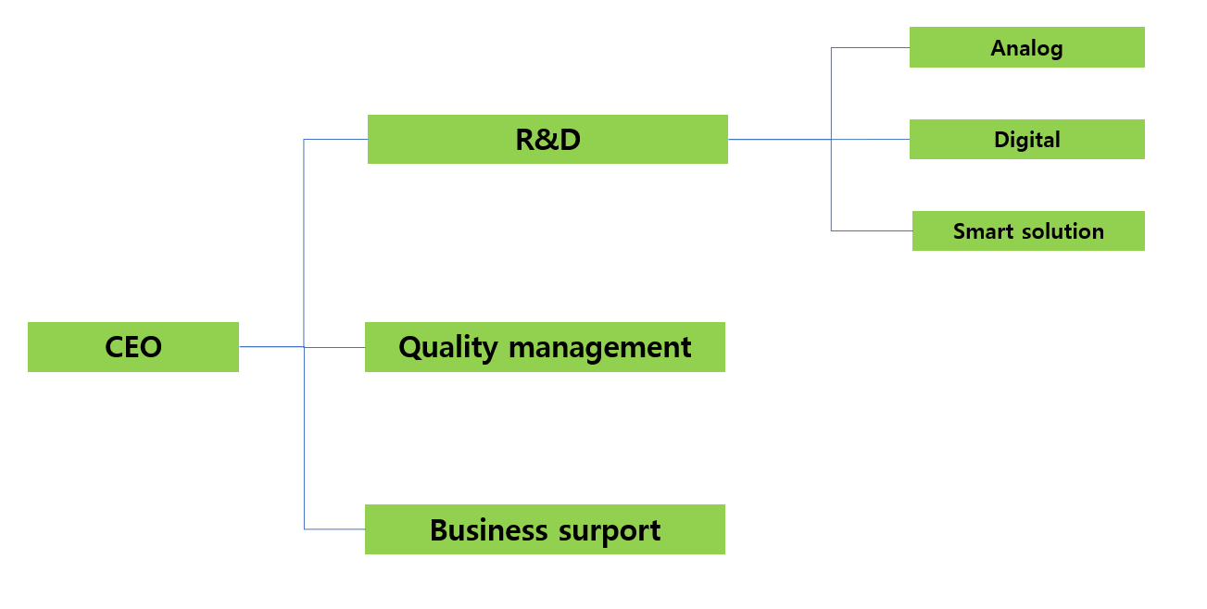

Phase #Ⅳ
[Applied scope]
1. Scope
This QMS standard specifies requirements for a quality management system where an organization.
a) need to demonstrate its ability to consistently provide products and services that meet customer and applicable statutory and regulatory requirements
b) aims to enhance customer satisfaction through the effective application of the system, including processes for improvement of the system and the assurance of conformity to customer and applicable statutory and regulatory requirements.

This quality manual was prepared based on the CEO’s quality policy and the IATF 16949:2016 standard. It is applied to all tasks related to development, production and additional services for automobile parts.

2. Reference standard
ISO 9001:2015 Quality management system

3. Process owner
The person in charge of each process is the management department specified in the process list, and after review by the department head, approval is obtained from the CEO.

Phase #1
[Company overview]
1. Company
ram-sChip.co.Ltd

2. Address
1F, 128ho, changup-ro 42, Sujung-gu,Seongnam-si, Gyeonggi-do, Korea, 13449

3. Product
Interface IP, Automotive IC.

Phase #2
[Quality policy]
RAMSCHIP QUALITY POLICY

RAMSCHIP.Inc develops market-leading innovative products based on an efficient quality management system, and maximizes our profits by stable supplying market(customer) oriented products with reliability through continuous improvement and securing productivity. And maximize customer & shareholder value.

● RAMSCHIP.Inc operates a quality management system with customer satisfaction
as top priority

● RAMSCHIP.Inc ensure the functionality and reliability toward customer
oriented products.

● RAMSCHIP.Inc supply defect-free products to the market through quality innovation
activities.

Sep.01.2022
ram-sCHIP CEO J.K. Ko.

Phase #3
[Process approach modeling]
3-1. Interrelationship between IATF COP and ram-sCHIP COP
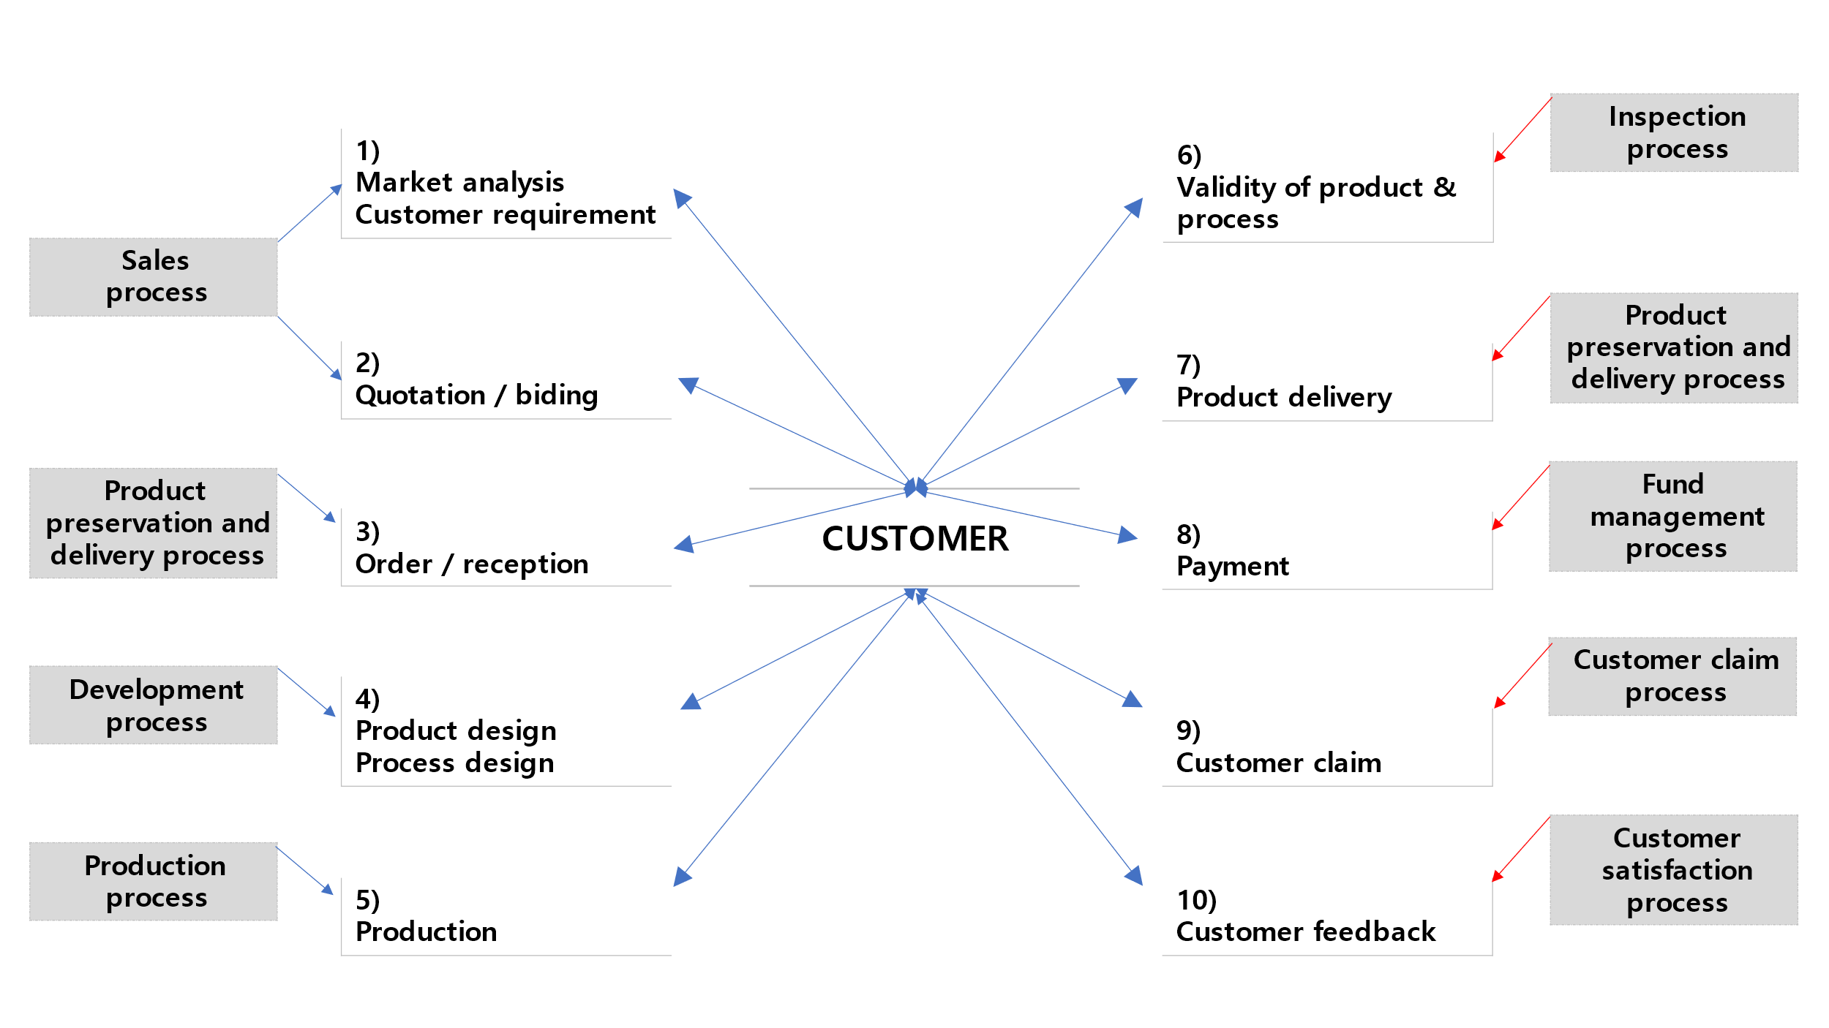

3-2. Process map of the ram-sCHIP quality management system.
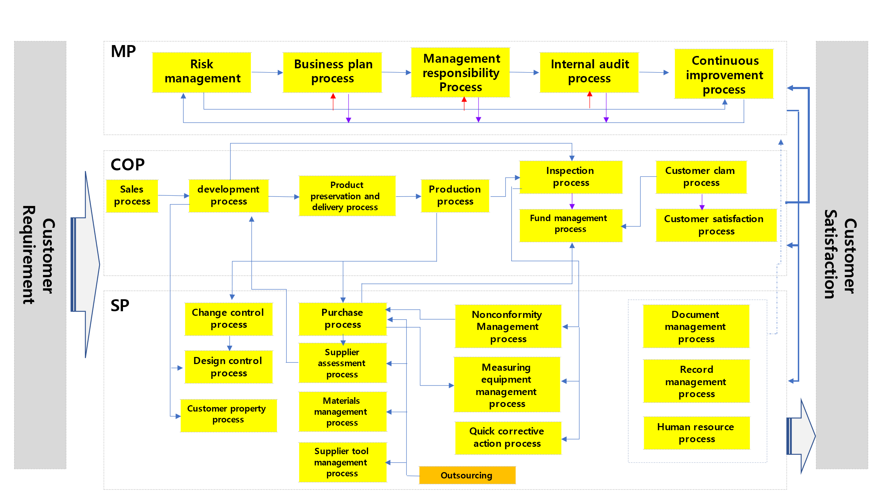
3-3. Interrelationship matrix between each process.

Classification |  | Support process (SP)
 |  | Document  Management  RS-SP-01 | Record  Management  RS-SP-02 | Design  Management  RS-SP-03 | HR  Management  RS-SP-04 | Change  Control  RS-SP-05 | Purchase  Management  RS-SP-06 | Supplier  Assessment  RS-SP-07 | Customer  Property management  RS-SP-08
Customer oriented process (COP) | Sales  RS-COP-01 | ● | ● | ● | ○ | ○ | ○ | ● | ●
 | Development  RS-COP-02 | ● | ● | ● | ○ | ● | ○ | ○ | ●
 | Production  RS-COP-03 | ● | ● | ○ | ○ | ○ | ○ | ○ | ●
 | Inspection  RS-COP-04 | ● | ● | ● | ● | ● | ○ | ○ | ●
 | Product preservation & delivery  RS-COP-05 | ● | ● | ○ | ○ | ○ | ● | ○ | ○
 | Customer satisfaction  RS-COP-06 | ● | ● | ○ | ○ | ○ | ● | ● | ●
 | Customer complaint  RS-COP-07 | ● | ● | ○ | ○ | ● | ● | ○ | ○
 | Fund management  RS-COP-08 | ○ | ○ | ○ | ○ | ○ | ● | ● | ○
( ● : Direct ○ : In-direct )

Classification |  | Support process (SP) |  |  |  |  | Management process (MP)
 |  | Material management  RS-SP-09 | Measuring equipment management  RS-SP-10 | Nonconformity  Management  RS-SP-11 | Supplier tool management  RS-SP-11 | Quick corrective action  RS-SP-12 | Risk management  RS-MP-01 | Management responsibility  RS-MP-02 | Business plan  RS-MP-03 | Internal audit  RS-MP-04 | Continuous improvement  RS-MP-05
Customer oriented process (COP) | Sales  RS-COP-01 | ● | ○ | ○ | ○ | ○ | ○ | ○ | ● | ● | ●
 | Development  RS-COP-02 | ○ | ○ | ○ | ○ | ○ | ● | ○ | ● | ● | ●
 | Production  RS-COP-03 | ● | ● | ○ | ○ | ● | ● | ○ | ● | ● | ●
 | Inspection  RS-COP-04 | ○ | ○ | ● | ● | ○ | ● | ○ | ● | ● | ●
 | Product preservation & delivery  RS-COP-05 | ○ | ● | ○ | ○ | ○ | ○ | ○ | ● | ● | ●
 | Customer satisfaction  RS-COP-06 | ● | ○ | ○ | ● | ○ | ○ | ○ | ● | ● | ●
 | Customer complaint  RS-COP-07 | ● | ○ | ○ | ● | ○ | ○ | ○ | ● | ● | ●
 | Fund management  RS-COP-08 | ● | ○ | ○ | ○ | ○ | ● | ○ | ● | ● | ●

( ● : Direct ○ : In-direct )

3-4. IATF16949:2016 Requirement and related process.

IATF16949:2016 | Process number | Process
4. Context of the organization | - | -
4.1. Understanding the organization and its context. | RS-MP-01 | Risk management process
4.2. Understanding the needs and expectations of interested parties. | RS-MP-01 | Risk management process
4.3. Determining the scope of the quality management system. | RS-QM-01 | Quality management system manual
4.3.1. Determining the scope of the quality management system.  - supplemental | RS-QM-01 | Quality management system manual
4.3.2. Customer specific requirements. | RS-QM-01 | Quality management system manual
4.4. Quality management system and its processes | RS-QM-01 | Quality management system manual
4.4.1.1. Conformance of products and processes. | RS-COP-4 | Inspection process
4.4.1.2. Product safety | RS-COP-02  RS-COP-03 | Development process  Production process
5. Leadership | - | -
5.1. Leadership and commitment | RS-QM-01 | Quality management system manual
5.1.1. General | RS-QM-01 | Quality management system manual
5.1.1.1. Corporate responsibility | RS-MP-02 | Management responsibility process
5.1.1.2. Process effectiveness and efficiency | RS-QM-01 | Quality management system manual
5.1.1.3. Process owner | RS-QM-01 | Quality management system manual
5.2. Policy | RS-QM-01 | Quality management system manual
5.2.1. Establishing the quality policy | RS-QM-01  RS-MP03 | Quality management system manual  Business planning process
5.2.2. Communicating the quality policy | RS-QM-01  RS-MP-03 | Quality management system manual  Business planning process
5.3. Organizational roles, responsibilities and authorities. | RS-QM-01 | Quality management system manual
5.3.1. Organizational roles, responsibilities and authorities.  - supplemental | RS-QM-01 | Quality management system manual
5.3.2. Responsibility and authority for product requirements and corrective actions | RS-QM-01 | Quality management system manual
6. Planning | RS-MP-01 | Risk management process
6.1. Actions to address risks and opportunities | RS-MP-01 | Risk management process
6.1.2.1. Risk analysis | RS-MP-01 | Risk management process
6.1.2.2. Preventive action | RS-MP-01 | Risk management process
6.1.2.3. Contingency plans | - | Emergency instruction
6.2. Quality objectives and planning to achieve them | RS-MP-03 | Business planning process
6.2.2.1. Quality objectives and planning to achieve them – supplement | RS-MP-03 | Business planning process
6.3 Planning of changes | RS-QM-01 | Quality management system manual
7. Support | RS-QM-01 | Quality management system manual
7.1 Resources | RS-QM-01 | Quality management system manual
7.1.1. General | RS-QM-01 | Quality management system manual
7.1.2. People | RS-SP-04 | HR management process
7.1.3. Infrastructure | RS-COP-03 | Production process
7.1.3.1. Plant, facility and equipment planning | RS-COP-02 | Development process
7.1.4. Environment for the operation of processes | RS-COP-03 | Production process
7.1.4.1. Environment for the operation of processes – supplement | RS-COP-03 | Production process
7.1.5. Monitoring and measuring resources | RS-SP-10 | Measuring equipment  management process
7.1.5.1. General | RS-SP-10 | Measuring equipment  management process
7.1.5.1.1. Measurement system analysis | RS-SP-10 | Measuring equipment  management process
7.1.5.2. Measurement traceability | RS-SP-10 | Measuring equipment  management process
7.1.5.2.1. Calibration/Verification records | RS-SP-10 | Measuring equipment  management process
7.1.5.3. Laboratory requirements | - | -
7.1.5.3.1. Internal laboratory | - | -
7.1.5.3.2. External laboratory | - | -

IATF16949:2016 | Process number | Process
7.1.6. Organizational knowledge | RS-QM-01 | Quality management system manual
7.2. Competence | RS-SP-04 | HR management process
7.2.1. Competence - supplemental | RS-SP-04 | HR management process
7.2.2. Competence – on-the-job training | RS-SP-04 | HR management process
7.2.3. internal auditor competency | RS-SP-04 | HR management process
7.2.4. Second party auditor competency | RS-SP-04 | HR management process
7.3 Awareness | RS-QM-01 | Quality management system manual
7.3.1. Awareness – supplemental | RS-QM-01 | Quality management system manual
7.3.2. Employee motivation and empowerment | RS-SP-04 | HR management process
7.4. Communication | RS-QM-01 | Quality management system manual
7.5. Documented information | RS-SP-01 | Document management process
7.5.1. General | RS-QM-01 | Quality management system manual
7.5.1.1. Quality management system documentation | RS-SP-01 | Document management process
7.5.2. Creating and updating | RS-SP-01 | Document management process
7.5.3. Control of documented information | RS-SP-02 | Record management process
7.5.3.2.1. Record retention | RS-SP-02 | Record management process
7.5.3.2.2. Engineering specifications | RS-SP-03  RS-SP-05 | Design management process  Change control process
8. Operation | - | -
8.1 Operation planning and control | RS-COP-01 | Sales process
8.1.1. Operation planning and control – supplemental | RS-COP-02 | Development process
8.1.2. Confidentiality | RS-COP-02  RS-SP-01 | Development process  Document management process
8.2 Requirements for products and services | RS-COP-02 | Development process
8.2.1. Customer communication | RS-COP-02 | Development process
8.2.1.1 Customer communication – supplemental | RS-COP-02 | Development process
8.2.2. Determining the requirements for products and services | RS-COP-02 | Development process
8.2.2.1. Determining the requirements for products and services  - supplemental | RS-COP-02  RS-COP-01 | Development process  Sales process
8.2.3. Review of the requirements for products and services | RS-COP-02 | Development process
8.2.3.1.1. Review of the requirements for products and services  - supplemental | RS-COP-02 | Development process
8.2.3.1.2. Customer-designated special characteristics | RS-COP-02 | Development process
8.2.3.1.3. Organization manufacturing feasibility | RS-COP-02 | Development process
8.2.4. Changes to requirements for product and services | RS-COP-02 | Development process
8.3. Design and development of products and services | - | -
8.3.1. General | RS-QM-01 | Quality management system manual
8.3.1.1. Design and development of product and services  - supplemental | RS-COP-02 | Development process
8.3.2. Design and development planning | RS-COP-02 | Development process
8.3.2.1. Design and development planning – supplemental | RS-COP-02 | Development process
8.3.2.2. Product design skills | RS-COP-02 | Development process
8.3.2.3. Development of product with embedded software | RS-COP-02 | Development process
8.3.3. Design and development inputs | RS-COP-02 | Development process
8.3.3.1. Product design input | RS-COP-02 | Development process
8.3.3.2. Manufacturing process design input | RS-COP-02 | Development process
8.3.3.3. Special characteristics | RS-COP-02 | Development process
8.3.4. Design and development controls | RS-COP-02 | Development process
8.3.4.1. Monitoring | RS-COP-02 | Development process
8.3.4.2. Design and development validation | RS-COP-02 | Development process
8.3.4.3. Prototype program | RS-COP-02 | Development process
8.3.4.4. Product approval process | RS-COP-02 | Development process
8.3.5. Design and development outputs | RS-COP-02 | Development process

IATF16949:2016 | Process number | Process
8.3.5.1. Design and development outputs – supplemental | RS-COP-02 | Development process
8.3.5.2. Manufacturing process design output | RS-COP-02 | Development process
8.3.6. Design and development changes | RS-SP-05 | Change control process
8.3.6.1. Design and development changes – supplemental | RS-SP-05 | Change control process
8.4. Control of externally provided processes, products and services | - | -
8.4.1 General | RS-SP-09 | Material management process
8.4.1.1. General - supplemental | RS-SP-09  RS-SP-06 | Material management process  Purchase management process
8.4.1.2. Supplier selection process | RS-SP-07 | Supplier assessment process
8.4.1.3. Customer-directed sources (also known as “Directed – Buy”) | RS-SP-07 | Supplier assessment process
8.4.2. Type and extent of control | RS-SP-07 | Supplier assessment process
8.4.2.1. Type and extent of control – supplemental | RS-COP-04 | Inspection process
8.4.2.2. Statutory and regulatory requirements | RS-COP-04  RS-SP-06 | Inspection process  Purchase management process
8.4.2.3. Supplier quality management system development | RS-SP-07 | Supplier assessment process
8.4.2.3.1. Automotive product-related software or automotive products | N/C | N/C
8.4.2.4. Supplier monitoring | RS-SP-07 | Supplier assessment process
8.4.2.4.1. Second-party audits | RS-SP-07 | Supplier assessment process
8.4.2.5. Supplier development | RS-SP-07 | Supplier assessment process
8.4.3. Information for external providers | RS-SP-07 | Supplier assessment process
8.4.3.1. Information for external providers - supplemental | RS-SP-06 | Purchase management process
8.5. Product and service provision | - | -
8.5.1. Control of production and service provision | RS-COP02 | Development process
8.5.1.1. Control plan | RS-COP02 | Development process
8.5.1.2. Standardized work – operator instructions and visual standards | RS-COP-03 | Production process
8.5.1.3. Verification of job set-ups | RS-COP-03 | Production process
8.5.1.4. Verification after shutdown | RS-COP-03 | Production process
8.5.1.5. Total productive maintenance | RS-COP-03 | Production process
8.5.1.6. Management of production tooling and manufacturing, test,  inspection | RS-SP-11 | Supplier tool management process
8.5.1.7. Production scheduling | RS-COP-03 | Production process
8.5.2. Identification and traceability | RS-COP-03-I-01 | Traceability instruction
8.5.2.1. Identification and traceability – supplemental | RS-COP-03-I-01 | Traceability instruction
8.5.3. Property belonging to customers or external providers. | RS-SP-08 | Customer property management  process
8.5.4. Preservation | RS-COP-05 | Product preservation & delivery  process
8.5.4.1. Preservation – supplemental | RS-COP-05 | Product preservation & delivery  process
8.5.5. Post-delivery activities | RS-COP-05 | Product preservation & delivery  process
8.5.5.1. Feedback of information from service | RS-COP-07 | Customer complaint process
8.5.5.2. Service agreement with customer | RS-COP-07 | Customer complaint process
8.5.6. Control of change | RS-SP-05 | Change control process
8.5.6.1. Control of change – supplemental | RS-SP-05 | Change control process
8.5.6.1.1. Temporary change of process controls | RS-SP-05 | Change control process
8.6. Release of products and services | RS-COP-04 | Inspection process
8.6.1. Release of products and services – supplemental | RS-COP-04 | Inspection process
8.6.2. Layout inspection and functional testing | RS-COP-04 | Inspection process
8.6.3. Appearance items | RS-COP-04 | Inspection process
8.6.4. Verification and acceptance of conformity of external provided  Products and services | RS-COP-04 | Inspection process
8.6.5. Statutory and regulatory conformity | RS-COP-04 | Inspection process
8.6.6. Acceptance criteria | RS-COP-04 | Inspection process
8.7. Control of nonconformity outputs | RS-SP-10 | Nonconformity management  process
8.7.1.1. Customer authorization for concession | RS-SP-10 | Nonconformity management  process

IATF16949:2016 | Process number | Process
8.7.1.2. Control of nonconforming product – customer specified process | RS-SP-10 | Nonconformity management  process
8.7.1.3. Control of suspect product | RS-SP-10 | Nonconformity management  process
8.7.1.4. Control of reworked product | RS-SP-10 | Nonconformity management  process
8.7.1.5. Control of repaired product | RS-SP-10 | Nonconformity management  process
8.7.1.6. Customer notification | RS-SP-10 | Nonconformity management  process
8.7.1.7. Nonconforming product disposition | RS-SP-10 | Nonconformity management  process
9. Performance evaluation | - | -
9.1 Monitoring, measurement, analysis and evaluation | RS-QM-01 | Quality management system manual
9.1.1. General | RS-QM-01 | Quality management system manual
9.1.1.1. Monitoring and measurement of manufacturing processes | RS-COP-03 | Production process
9.1.1.2. Identification of statistical tools | RS-MP-05 | Continuous improvement process
9.1.1.3. Application of statistical concepts | RS-COP-02  RS-MP-05  RS-COP-03 | Development process  Continuous improvement process  Production process
9.1.2. Customer satisfaction | RS-COP-06 | Customer satisfaction process
9.1.2.1. Customer satisfaction – supplemental | RS-COP-06 | Customer satisfaction process
9.1.3. Analysis and evaluation | RS-COP-06 | Customer satisfaction process
9.1.3.1. Prioritization | RS-COP-06 | Customer satisfaction process
9.2 Internal audit | RS-MP-04 | Internal audit process
9.2.2.1. Internal audit program | RS-MP-04 | Internal audit process
9.2.2.2. Quality management system audit | RS-MP-04 | Internal audit process
9.2.2.3. Manufacturing process audit | RS-MP-04 | Internal audit process
9.2.2.4. Product audit | RS-MP-04 | Internal audit process
9.3. Management review | RS-MP-02 | Management responsibility process
9.3.1. General | RS-MP-02 | Management responsibility process
9.3.1.1. Management review – supplemental | RS-MP-02 | Management responsibility process
9.3.2. Management review inputs | RS-MP-02 | Management responsibility process
9.3.2.1. Management review inputs – supplemental | RS-MP-02 | Management responsibility process
9.3.3. Management review outputs | RS-MP-02 | Management responsibility process
9.3.3.1. Management review outputs - supplemental | RS-MP-02 | Management responsibility process
10. Improvement | RS-QM-01 | Quality management system manual
10.1 General | RS-QM-01 | Quality management system manual
10.2 Nonconformity and corrective action | RS-SP-11 | Nonconformity management  process
10.2.3. Problem solving | RS-SP-11  RS-SP-12 | Nonconformity management  Process  Quick corrective action process
10.2.4. Error-proofing | RS-SP-11 | Nonconformity management  process
10.2.5. Warranty management systems | RS-COP--07 | Customer complaint process
10.2.6. Customer complaints and field failure test analysis | RS-COP--07 | Customer complaint process
10.3 Continual improvement | RS-MP-05 | Continuous improvement process
10.3.1. Continual improvement – supplemental | RS-MP-05 | Continuous improvement process

3-5. Process owner
Classification | PROCESS | QA | Admin | R&D | Sales | Production | Purchase
COP  (Customer  Oriented Process) | Sales process |  |  |  | ●
 | Development process |  |  | ●
 | Production process |  |  |  |  | ●
 | Inspection process | ●
 | Product preservation  & Delivery process |  |  |  |  | ●
 | Customer satisfaction  Process | ●
 | Customer complaint  Process | ●
 | Fund management  Process |  | ●
SP  (Support Process) | Document management  Process | ●
 | Record management  Process | ●
 | Design management  Process |  |  | ●
 | HR management  process | ●
 | Change control process | ●
 | Purchase management  Process |  |  |  |  |  | ●
 | Supplier assessment  Process |  |  |  |  |  | ●
 | Customer property  Management process |  |  |  | ●
 | Material management  Process |  |  |  |  | ●
 | Measuring equipment  Management process | ●
 | Nonconformity management process | ●
 | Quick corrective action  Process | ●
MP  (Management  Process) | Risk management  Process |  | ●
 | Management responsibility process | ●
 | Business plan process |  | ●
 | Internal audit process | ●
 | Continuous improvement process | ●

Phase #4
[Social responsibility]
Social responsibility
Code of conduct | 1) All employees contribute to the company’s best interests rather than interests  2) Conduct own job effectively and efficiently  3) Should avoid taking improper personal advantage by utilize personal position  4) Compliance with company policies and legal requirements.  5) Protection and appropriate use of the company’s property.  6) Company confidentiality prohibited: 3rd party  7) No discrimination against partners, competitors and employees  8) Protection of human rights
Anti-corruption | 1) All executives and employees should not bribe third parties for profit  (public institutions/this party): gifts, entertainment…..  2) All executives and employees shall not use their positions to request money or  entertainment for cooperation  3) should not illegally use or embezzle the company's money.
Whistle blow | 1)
All employees should understand the above information and faithfully fulfill the stipulated responsibilities and authority.

Sep.01.2022
ram-sCHIP CEO J.K. Ko.

Phase #5
[Division of duties]
Team | Job | Team | Job
Common | -. Development work  -. Customer property work  -. Internal / External audit work  -. Data analysis work  -. Risk management / preventive actions  -. Proposal work  -. Nonconformity / corrective actions | Quality | -. Customer claim handling  -. Nonconformity product management  -. Abnormal product handling  -. Customer audit  -. APQP Process management  -. Quality data recording  -. Measurement system analysis  -. Quality data analysis for improvement  -. Internal audit  -. Management review host  -. Risk management & preventive action.  -. Continuous improvement  -. Process & product monitoring  -. Product qualification  -. Measurement facility’s calibration & verification host  -. QMS management  -. Document management  -. SCM (Supply chain management)  -. AVL(Approved vendor list) management  -. Supplier assessment
Development | -. Development work  -. Drawing & design management  -. Change control management
Production | -. Yearly production planning  -. Process optimization work  -. Yield up activity  -. Production management  -. Product shipping management  -. Nonconformity management  -. Product traceability management  -. Product repair history recording

Team | Job | Team | Job
Purchase | -. AVL(Approved vendor list) management  -. Supplier assessment  -. Material purchase (if necessary)  -. Negotiation works  -. SCM (Supply chain management) | Admin | -. HR (Human resource) management  -. Accounting work  -. Fund management  -. Business planning host  -. Internal communication  -. Organizational culture management  -. Risk management & preventive plan  -. Time and attendance management  -. Company property management  -. Management of the proposal system.  -. Patent management  -. Execution of funds for purchasing items.
Sales | -. Estimate business  -. Customer service  -. Order work from customer  -. Customer property management  -. Country of origin management of raw  material or parts.  -. Sales strategy planning  -. Market situation analysis

Phase #6
[Management review]
Meeting | Agenda | Freq | Attend | Owner
Development meeting | -. Development feasibility review  -. Development goal review  [Quality / Cost / Delivery] | Weekly | -. Sales  -. Quality  -. Purchase  -. Production | Development
Monthly  Biz review meeting | -. Each KPI review  -. Production issue review  -. Quality issue review  -. Sales issue review  -. Development issue review | Monthly | -. All dept | Quality
Biz strategy meeting | -. Business strategy review  -. Company risk review | Half year | -. Admin  -. Board members | Admin

